**Institute of Engineering & Management**

**Department of Computer Science & Engineering**

**Software Tools Laboratory for 2nd year 4th Semester 2018**

**Code: CS 492**

**Date:** 13/03/2018

**Week-5**

**Assignment-1**

**Problem Statement:** Implement the drive list box, dir list box and file list box control in a VB form.  
For every changes in the name of the drives, the name of the directories must be changed. And by selecting every directory, the list of files must be viewed in the file list box. When you click on the each and every file in the file list box, the file name will be displayed through a message box with the information style. Write this program with suitable VB code snippet.

**Screen-Shot:**

**Form-1:**

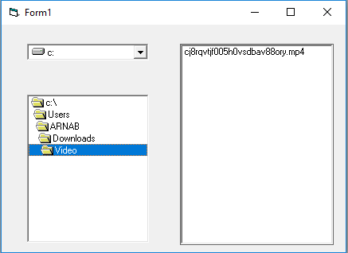

Pic-1: After selecting drive and directory

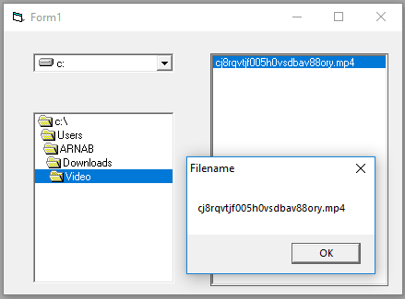

Pic-2: After selecting the file

**Form Code:**

**For Form-1:**

Private Sub Drive1_Change()

Dir1.Path = Drive1.Drive

End Sub

Private Sub Dir1_change()

File1.Path = Dir1.Path

End Sub

Private Sub File1_Click()

Call MsgBox(File1.FileName, vbOKOnly, "Filename")

End Sub

**Assignment-2**

**Problem Statement:** Create an application in VB6 so that user can choose a .jpeg/.jpg image from hard disk and able to view that.

**Screen-Shot:**

**Form-1:**

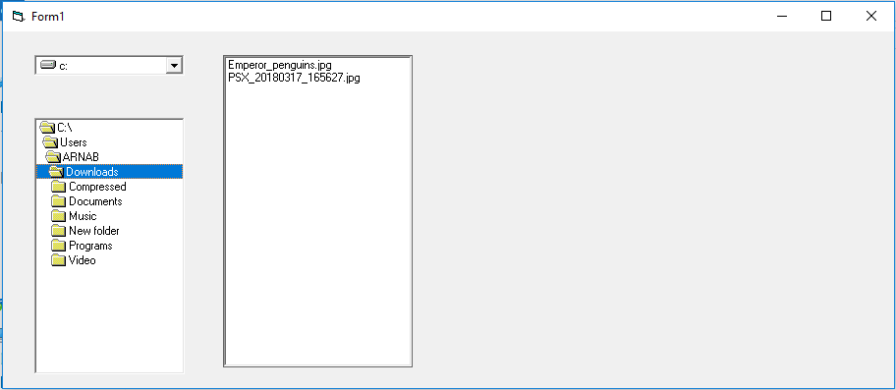

Pic-1: After selecting the drive and the directory

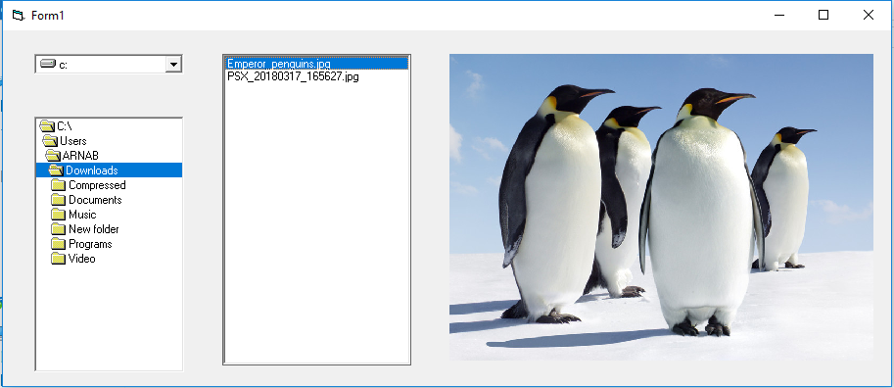

Pic-2: After selecting the Image

**Form Code:**

**For Form-1:**

Private Sub Drive1_Change()

Dir1.Path = Drive1.List

End Sub

Private Sub Dir1_Change()

File1.Path = Dir1.Path

End Sub

Private Sub File1_Click()

Image1.Picture = LoadPicture(File1.Path + "\" + File1.FileName)

End Sub

Private Sub Form_Load()

File1.Pattern = "*.jpeg;*.jpg"

End Sub